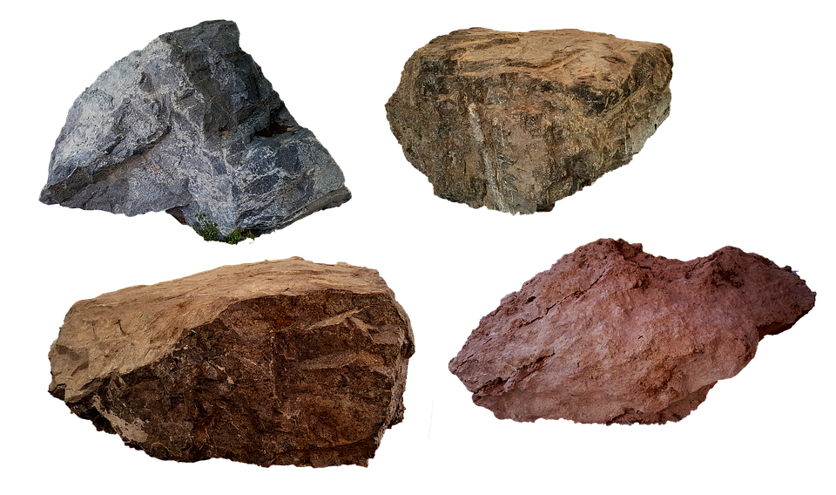
LI: To identify different types of rocks and how they are formed
Follow the steps in the powerpoint to do the chocolate rock experiment or watch the video. When you are done, draw each rock formation and label the different parts of each rock.
When you are done with your drawings, can you describe how the different rocks are made in nature?

Sedimentary rock: | How is it made?
Metamorphic rock: | How is it made?
Igneous rock: | How is it made?

